Inelastic scattering spectrometer simulation (with BRISP)
E. Farhi, Institut Laue Langevin (ILL), Grenoble, France
farhi@ill.eu <www.mcstas.org> - June 2009
Abstract
This document is a tutorial about McStas and neutron scattering for beginners. We shall study the BRISP instrument, mainly with liquid samples.

Prerequisites
- Undergraduate knowledge of mathematics and physics
- A computer with McStas installed (refer to the McStas homepage <www.mcstas.org> for details) or a bootable McStas Ubuntu live DVD (installation to harddisk possible, but not required)
- This paper

Basic McStas description
In short, the core of the McStas system is a precompiler. It reads an instrument description (made of components just as in real world), and creates a simulation of it. Optionally, the program takes input arguments to tune the setup of your instrument/simulation.
Example of McStas components are Sources, Optics (such as Monochromators, Collimators and Choppers), Detectors/Monitors (which produce data files), and Samples (such as powders, liquids, polymers, crystals, …).
Each neutron event is stored as a 'particle' with a position (x,y,z), a velocity (vx, vy, vz), a time (t), a Monte Carlo weight (p) and optionally a neutron spin (sx,sy,sz). When propagating inside the simulation model, the neutron event weight decreases (statistical probability to be there), altered by the physics laws (scattering, absorption, ...). The sum of all weights is the neutron flux.

In order to follow the simulation results, it is usual to position more detectors than in the real world, all along the model. Additionally, these so-called monitors can be more versatile than simple gas tubes, which are at best sensitive to position. In simulations, it is very cheap to add all kinds of virtual monitors everywhere: wavelength, time, energy, position, ...

Starting McStas (and optionally installing)
- Put the McStas 1.12a DVD-ROM in your laptop disk drive
- Boot the PC and copy files BRISP.instr and Pb_liq_*.* to the Home Folder.
- Ask me to 'optimize' your configuration (VRML plotter, C compiler/options, multi-core, ...)
- Click on the McStas icon to start McGUI

You can optionally install Ubuntu+McStas (Install icon, 4Gb) or McStas alone on /cdrom/McStas1.12a.

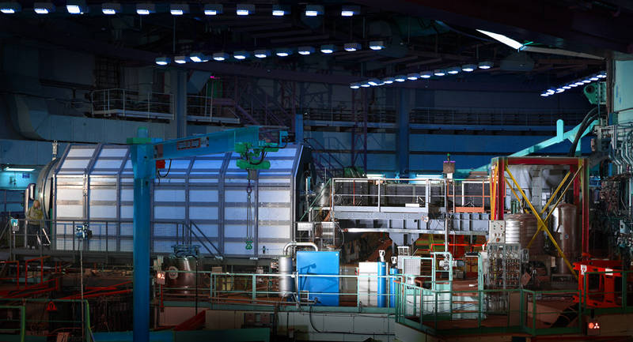
BRISP
Time of Flight Neutron Spectrometer for Small Angle Inelastic Scattering

Warning: in this tutorial, most of my questions are silly, so I expect that you give me silly answers !

A-Understanding the simulation model BRISP.instr

Starting
- Click on the McStas icon
- Select menu File/Open instrument and choose the BRISP.instr (in /home/ubuntu)
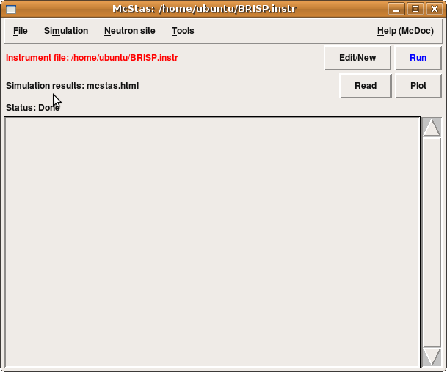
Figure 1: The McGUI main McStas window (mcgui)

- The simulation model reflects the actual BRISP geometry, as seen in Figure 2.
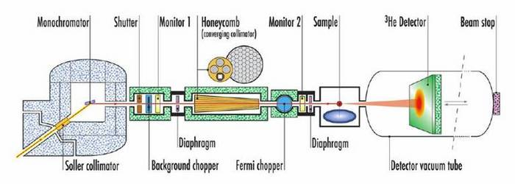
Figures 2: side view of the BRISP instrument
The BRISP.instr model was assembled and tested for you. Optionally, you may have a look at its description by clicking on the Edit/New button (top right side of McGUI). It consists in a list of components positioned in space, with intercalated C code. Close the editor window afterwards.
- Click on the Run button (on the top right side)
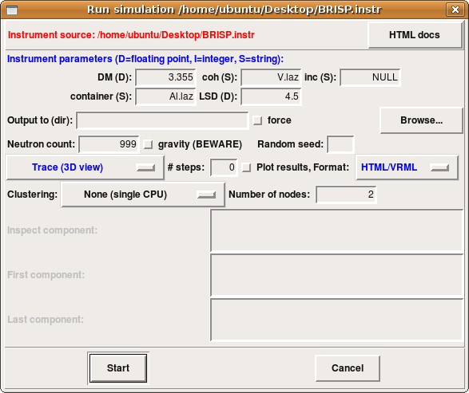

Figure 3: TheMcGUI/Run window. Notice the number of events (here 999), the execution mode (here Trace) and the output format (here HTML/VRML)

3D view of the instrument (virtual reality)
- Set 'neutron counts' to 999. Putting too many events here will generate a very large data file.
- Change the plot results format from PGPLOT to HTML/VRML
- Start the simulation in Trace 3D mode with VRML viewer and 999 events.
- A 3D view of the instrument appears (freewrl)
- In Freewrl, select from the Navigate menu the Walk mode.
- Right-click and move mouse up to elevate to the BRISP main platform.
- Left-click and move mouse up to start walking towards the instrument.
- Question 1: Identify the monochromator, the disk chopper, the Honeycomb focusing guide, the Fermi chopper, the sample, and the detector.

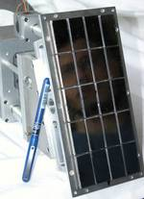
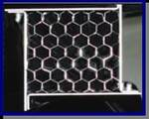

Figure 4: To help you answering Question 1, we provide images of some real devices: monochromator (left) and honeycomb focusing collimator (right)

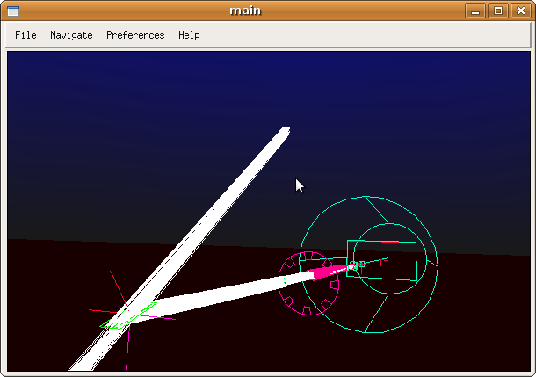
Figure 5: A 3D view of BRISP with FreeWRL.
Use mouse and left/right buttons in Walk mode to wander around.

Once completed, close the 3D view and return to the McGUI main window.

Configurations and resolution – Vanadium sample
We shall now start to perform simulations of the BRISP spectrometer. For this purpose, we have defined as input parameters:

- the monochromator lattice spacing (distance between atoms, in Angstroem=10⁻¹⁰ m). The default is a graphite 'PG002' (DM=3.355 Å).
- the sample definition and its container. The sample is positioned in a f=10 cm cryo-furnace modeled here as surrounding aluminium shield. The default sample is a Vanadium powder.
- the sample-to-detector distance (LSD=4.5 m, that we won't change)

As you may know (or not), BRISP has 3 main configurations, which define the neutron beam energy. Changing the configuration is done by changing the monochromator (graphite or copper). Monochromators are crystals that scatter neutrons by the mighty power of the Bragg's law:

nl = 2d sin(q)

where l, d and q are the neutron wavelength [Å], the lattice spacing [Å] and the scattering angle [radians] respectively. The integer n is the order of the reflection. The neutron energy [meV] can be obtained from its wavelength with the formula:

E = 81.8 / l²

Question 2: For the default graphite 'PG002' (d=3.355 Å) monochromator, compute the expected neutron wavelength l and energy E_{i} deflected by the monochromator, knowing the inclination of the beam tube 17.5º.
note: If you need a calculator, you can find one in the Ubuntu top left menu Applications/Accessories/Calculator.

Click on the Run button (top right side of McGUI)
- The sample should be set as incoherent part V.laz and coherent NULL. The container can be set to V.laz or NULL as well. Vanadium is mainly an incoherent scatterer.
- Set 'neutron counts' to 1e7
- Change the plot results format to PGPLOT
- Specify a directory where to store results 'Output to (dir)' as for instance 'run1'.
- Press the Start button and wait until the simulation ends (e.g. less than 30 seconds).
- Click on the Plot button to display results from each monitor/detector in the simulation.

We shall now take a look at all these plots. Units are usually in S.I. [m, s], except a few in [meV] and [Å].

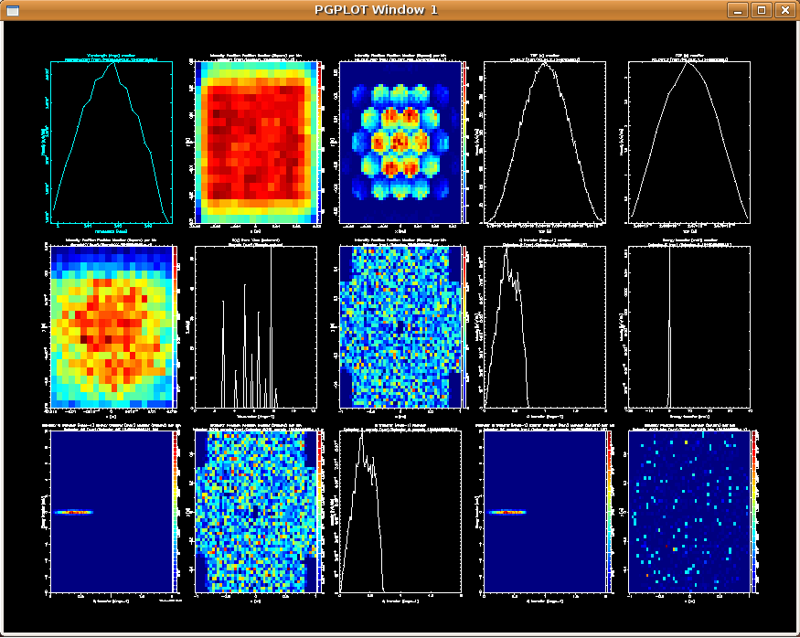
Figure 6: results from the BRISP simulation with PG002 monochromator and Vanadium sample. Press the 'L' key on the window to toggle log-scale mode. Click on sub-plots to enlarge them. Statistics are given above each enlarged plot (total flux I, centers X0 and Y0, gaussian half width dX and dY),

The name of detectors in the simulation have been defined 'reasonably', and appear in the order from the source to the end of the instrument.
- Do you think the beam is monochromatic ? You may estimate the monochromaticity from the wavelength spread ratio dl/l (1st plot).
- What is the beam size reflected by the monochromator (2nd plot) ?
- What does represent the 3rd plot ? Can you give an explanation for this geometry ?
- What is the mean travel time between the 2 choppers (plots 3,5)? Knowing the distance between the 2 choppers L=4.04 m, compute the neutron speed v.
- What is the beam size at the sample position (plot 6) ? Is it big/small ?
- What is the energy resolution at the final detector (plot 10, Detector_E) ?
- The spatial distribution of flux on the detector is shown in plot 7 Detector (the ones with a cross shape). How does it look-like ? Is is fair to call the Vanadium an isotropic scatterer ?

Repeat these steps with the 2nd order reflection on graphite (PG004 n=2, d=3.355 Å), and the copper crystals (Cu111 d=1.677 Å). Report your run2 and run3 results in the following table.

Monochromator d-spacing/order | Wavelength [Å] and energy [meV] | Wavelength spread dl/l [%] | Neutron speed v [m/s] | Energy resolution dw/w [meV]
Table 1: BRISP configurations (your results)

Scattering on liquid lead (Pb) – Structure and dynamics
We shall now use a more complex sample, which is a liquid lead, in an aluminium slab container, in the PG002 graphite configuration. The sample model was obtained from an ab-initio molecular dynamics simulation.
Click on the Run button (as usual) and change

DM=3.355 coh=Pb_liq_coh.sqw inc=Pb_liq_inc.sqw container=Al.laz

Set 'neutron counts' to 1e7, change the output directory to run4.
Press Start and wait a few minutes (time for a coffee break, or read the following note).

Reminder – About liquids and neutron scattering

Liquids are made of atoms which are arranged randomly in space, in a compact form (that is they 'touch' each other). In a gas, these distances are larger, and atoms do not touch each other. Within randomness, atoms still arrange in a semi-ordered way as they form layers of 1st, 2nd, … neighbours. The probability to find a given neighbour at a distance r from a central atom is usually called the radial distribution function (e.i. RDF) g(r). This function starts at g(0)=0 then reaches a maximum at the most probable and smallest neighbour distance r_{m}, and then oscillates with maximum at each neighbour shell distance. The static structure factor S(q) with momentum (wavevector) q=2p/r is defined as the spatial Fourier transform of g(r). It can be demonstrated that in liquids

This function can be almost directly measured with neutron diffractometers and spectrometers, and it is a characteristics of the liquid structure (atomic arrangement).
Additionally, atoms vibrate around their equilibrium position (e.g. thermal vibrations and sound waves). These movements, traveling with a velocity v such that q=mv, transport some energy w, that may be transferred to neutrons. For w=0, there is no energy transfer with neutrons, and the interaction is elastic (structure only). But, if neutrons gain or loose energy, this is the sign of an inelastic contribution such as phonons (sound waves – the same that you hear !). For small velocities and energies, the slope cw/q in normal liquids is the sound velocity. We may then extend the function S(q) onto the energy axis, and obtain the so-called dynamic structure factor S(q,w). This function is a characteristic of material structure and dynamics.
In a few words, a spectrometer like BRISP is specifically designed to measure the vibrations (e.g. sound waves) in liquids.

Now that the simulation is over, you can plot the results (click on the Plot button). You will immediately notice that the simulation should have been much longer (some plots are really noisy). As you do not want to sleep in front of the laptop, I have prepared two simulation results with liquid lead, with graphite and copper monochromator configurations.

From the Tools menu, select 'Open other results' and choose the file l-Pb/mcstas.sim (PG002 graphite configuration). Click on Open. The results obtained with 80 processors running for 20 minutes show up.

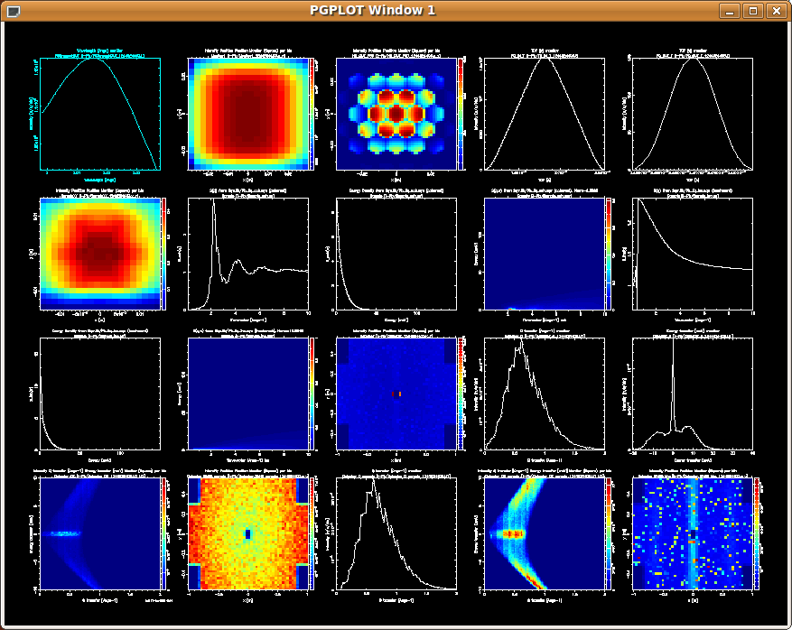
Figure 7: results from the BRISP simulation with PG002 monochromator and l-Pb sample.

Let's comment on some of the plots:
- Plot 7 shows the theoretical structure factor S(q) from the sample, and the plots 14 and 18 show what we can measure from it with BRISP. You will notice that plot 7 q-range goes far beyond the measurement on plot 14. What is the typical length scale accessible by BRISP ?
- If we plot the simulation results on an energy axis (plot 15), we can see an intense central peak at w=0, and shoulders. Are these elastic or inelastic contributions ?
- If we plot the simulation results on an energy axis and a 2p/r axis, we obtain the measured S(q,w), shown in plots 16 and 19. As a comparison, the theoretical structure factor is shown in plot 9 (only on the positive energy side. Use the L key to toggle the log scale). What can you say about the ability of BRISP to measure the sample dynamics ?
- The measurement limitations in wave-vector and energy are called the dynamic range. It depends on the incoming neutron energy. How can we simply extend the dynamical range, in order to better see the structure and the dynamics ?

From the Tools menu, select 'Open other results' and choose the file l-Pb2/mcstas.sim (Cu111 copper configuration). Click on Open. Results show up.
- Do you believe this configuration is better suited than the graphite one to measure the structure and the dynamics from liquid lead ? In particular, compare the measurable q-range from plot 14.
- What is the disadvantage of this copper configuration compared to the graphite one ? You can use results from the Table 1.

Now that you had a first contact with BRISP, you are ready to come on the real instrument (and understand better how it works, and what kind of results can be obtained).

