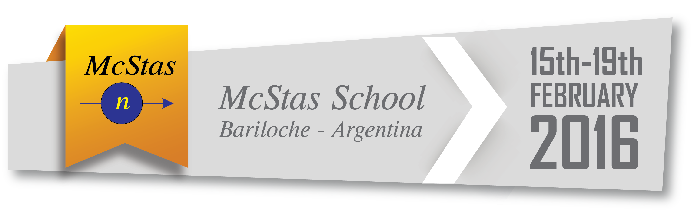

Instructors
Emmanouela Rantsiou | emmanouela.rantsiou@psi.ch | ER
Christine Klauser | christine.klauser@psi.ch | CK
Peter Willendrup | pkwi@fysik.dtu.dk | PW
Emmanuel Farhi | farhi@ill.fr | EF

Preliminary work
Installation
  - Install McStas 2.2a from http://mcstas.org/
  - We also recommend to install a VRML viewer such as view3dscene or InstantPlayer
  - An alternative solution is to burn a DVD or run a virtual machine from our ISO at http://mcstas.org/ubuntu/

Getting started
  - Perform the SANS tutorial available here: https://github.com/McStasMcXtrace/McCode/wiki/McStas-tutorial%3A-simplified-SANS-instrument
  - Optionally up to task 5.6 in http://mcstas.org/documentation/tutorial/

Day 1 – Monday Feb 15th 2016
9:00 – 10:30 | Welcome  1 - Introduction to McStas  Installation help (optional)  Forming groups of 2  Guided hands-on session (participants repeat the demo) | FC  PW  PW
10:30 - 11:00 | Coffee break
11:00 - 12:30 | 2. Sources and monitors | ER
12:30 - 14:00 | Lunch
14:00 - 15:30 | 3. Guides  Linear guide  Curved guide  Ballistic guide | CK
15:30 - 16:00 | Coffee break
16:00 - 17:30 | 4. Capture flux, guide losses  Capture flux estimates  Guide losses | EF

Day 2 – Tuesday Feb 16th 2016
9:00 – 10:30 | 5. Monochromators  Monochromator_flat / Monochromator_curved  Single_crystal | PW
10:30 - 11:00 | Coffee break
11:00 - 12:30 | 6. Stationary beam ‘tailoring’  Slits  Collimators | ER
12:30 - 14:00 | Lunch
14:00 - 15:30 | 7. Moving optics  Velocity selector  Disk chopper  Fermi chopper | CK
15:30 - 16:00 | Coffee break
16:00 - 17:30 | 8. Detectors  Gas detectors  CCD scintillators | EF

Day 3 – Wednesday Feb 17th 2016
9:00 – 10:30 | 9. Samples  Incoherent  PowderN  Single_crystal | ER  PW  PW
10:30 - 11:00 | Coffee break
11:00 - 12:30 | 9. Samples, cont'd  Isotropic_Sqw  SANS | EF  CK
12:30 - 14:00 | Lunch
14:00 - 15:30 | 10. Advanced language features  EXTEND, JUMP, COPY, GROUP, …  Example: Estimating background from mechanics | PW
15:30 - 16:00 | Coffee break
16:00 - 17:30 | 11. Sample environments  Concentric geometries | EF

Day 4 – Thursday Feb 18th 2016
Final planning for this day depends on feedback/discussion of interests of participants.
The timing may be changed during the course.

9:00 – 10:30 | 12. Complete instruments for reactors  Diffractometer  SANS | EF
10:30 - 11:00 | Coffee break
11:00 - 12:30 | 12. Complete instruments for reactors  Radiography / imaging  Laue diffractometer | EF
12:30 - 14:00 | Lunch
14:00 - 15:30 | 13. A tour of the example instrument library - Instructor: PW  with selected highlights | PW
15:30 - 16:00 | Coffee break
16:00 - 17:30 | 14. Open session : let's show you what you need  You have requests, we show you how to solve it | All

Day 5 – Friday Feb 19th 2016
Probably form small groups and work to answer requests. Any unexpected delay from Days 1-4 will go there.

